THE CORE THEATRE SOLIHULL TICKETING & PUBLICITY FORM

Complete and return this form in order for us to set up and sell tickets and publicise your event.
ABOUT YOU (This also means Group / Club / Company / Society etc. as appropriate)

NAME___________________________________________________________________________

Address__________________________________________________________________________

Postcode ____________ e-mail____________________ Ticket Contact_________________

Daytime Tel. No:____________________________ Mobile________________________________

ABOUT YOUR TICKETS (This info will be shown on your tickets)

TITLE of Show / Event _____________________________________________________________

Show presented by (optional i.e. Promoter/Society)______________________________________

Second line text (optional)___________________________________________________________

Venue (Theatre/ Studio other) _______________________________________________________

Concession prices: Where offered MUST include:- Senior 60+, Student, Unwaged, Disabled & Child at the same reduced price (except optional different child price see * in box below).
You can add your own (i.e. your own members concession) if you wish, please state it here:-

Similarly Group Booking discount is optional but where selected, 1 free in 10 is the only group booking offered. Do you want group discount? Circle here: YES PLEASE / NO THANKS.

Date tickets go on sale to the general public ___________ (allow 10 days notice)
Day | Date | Start Time | Full Price | Concession | *Child | Office code
Monday
Tuesday
Weds
Thursday
Friday
Sat mat
Sat eve
Sun mat
Sun eve
Show running time: _____mins. Interval (always 20mins) Yes / No at ____: ____am/pm

The Core offers up to 4 complimentary tickets per show for hirer/promoter use for shows in the main house (2 for shows in the Studio). These tickets are issued at the venue’s discretion. Would you like to reserve any of these tickets? YES / NO how many?__

ABOUT YOUR SHOW This information helps us sell your tickets using print/website and should be valid, correct and true. Please check carefully all info including writers, songs, content, suitability etc. as improper advertising can lead to complaints and refunds. You must notify us of any amendments as soon as you become aware. i.e. change of support act/performer or content.

SHOW INFORMATION. Brief description to include; suitable age range, any author/composers, brief plot, hit songs, swearing, nudity or strong content. Use a separate sheet if you need to explain.

Suitable for ages: (when left blank we will assume ANY age)

PRINTED PUBLICITY: Send print to the venue as early as possible – we don’t make any guarantees regarding display. For overprinting please use this info:- The Core Theatre Solihull. Box Office 0121 704 6962. www.thecoretheatresolihull.co.uk please don’t use previous names.

IMAGES & LOGO: We need a good quality image, supplied as a jpeg file emailed to thecoretheatre@solihull.gov.uk and clearly titled with show title/date.

OTHER CONTACTS (if different from those you have given overleaf)

Membership contact for people interested Marketing contact regarding print, pics or
in joining your group/classes (if applicable). other publicity matters (if applicable).

Name______________________________ Name______________________________

Daytime Tel_________________________ Daytime Tel_________________________

WEBSITE & ONLINE SALES
We may promote your show on our website unless you write NO here ........
We may promote and sell your tickets ONLINE unless you write NO here ........

Please read all the accompanying information before signing this form as you are agreeing to our website, ticketing & publicity terms and conditions. Keep info sheets for your future reference. Please speak to staff if you are unsure or have queries regarding your show.

Signed _______________________________ Print Name_________________________________

Title Date

TERMS & CONDITIONS FOR HIRERS – SEATS, TICKETS & PUBLICITY

These terms and conditions apply to all performances at The Core Theatre Solihull (formerly Solihull Arts Complex) and where appropriate, to events/tickets being sold for other venues or promoters.

SEATS - THEATRE
- The total available seats in the Theatre is 336 and cannot be exceeded. No other persons can remain without a seat nor sit/stand in aisles or along the back wall, this is a legal Fire Regulation requirement and is strictly adhered to at all times.

- Back row seats no longer have restricted legroom as shown in seating plan (except P7).

- Seats P14 – P17 form part of the permanent sound desk and these seats are always off-sale.

- For wheelchairs, seats A1–A4 & A14–A17 remove in pairs. Maximum wheelchairs 3 each side (and no other seats). Seats A5–A13 remove in threes, maximum wheelchairs here 6 (and no other seats). When one block of 3 seats are removed for a wheelchair a single loose seat can inserted adjacent. Both the front row (and overall) seating capacity will be reduced for the first and each subsequent wheelchair booking. Group selling their own tickets MUST inform Box Office of all wheelchair bookings on Row A to check their sale is correct..

- Theatre shows are always reserved seating i.e. A1, B2, etc. Studio shows are generally reserved seating but can be unreserved in certain circumstances, at the discretion of the venue.

TICKETS
- Child ticket sales apply to children aged 18 months up to 16 years. Student ticket concessions apply to those in full time education. Unwaged refers to those on Jobseeker Benefits whilst Senior concession applies to those aged 65+. Proof may be requested for any concession either at box office or upon entry to the show.

- Carer seats. These are for carers of people who cannot access or exit the building unaided in an emergency situation, this is usually for wheelchair users and people who are registered blind, but can also include people with other conditions. Carer seats will show a zero value, on the Hirers Final Show Report. Carers should obtain and show their CARERS card.

- Groups bookings should be carefully managed by hirers and/or Box Office to ensure smooth arrival/exit and appropriate seating for the groups size and mobility.

- There is a 'No exchange or refund policy' on all tickets. This is mentioned at point of sale both within our office and online. Hirers selling tickets themselves must give buyers this correct info, particularly regarding refunds and wheelchairs etc.

- If show is cancelled by hirer, they will refund any tickets they have sold themselves whilst the venue will refund any tickets sold through Box Office at a refund fee per ticket (currently £2 + vat). No booking fees can be refunded for tickets sold online. Hirers should check the venues:- Hire Cancellation Policy, Refund Policy and Cancelled Show Policy prior to booking.

- Staff cannot 'manage' guest lists for hirers, artists, or promoters, but are happy to assist.

- Hirers MUST use venue printed tickets, no other ticketing is allowed within this venue.

- Tickets cannot be put on sale until a signed HIRE CONTRACT has been received by the Venue Hire staff to ensure that the show date is accurate and deposit paid.

Hirers should call Box Office on 0121 704 6962 during normal office hours with any queries, or if your query remains unresolved, contact the Marketing Manager on 0121 704 6979.

By signing you are deemed to have read and agreed to the contents relating to your own event. Failure to read this form and make appropriate checks regarding these terms and conditions could result in errors and complaint leading to refunds/charges for which the venue cannot be held responsible and will be passed onto the Hirer or Promoter.

SEATING PLAN FOR THEATRE.

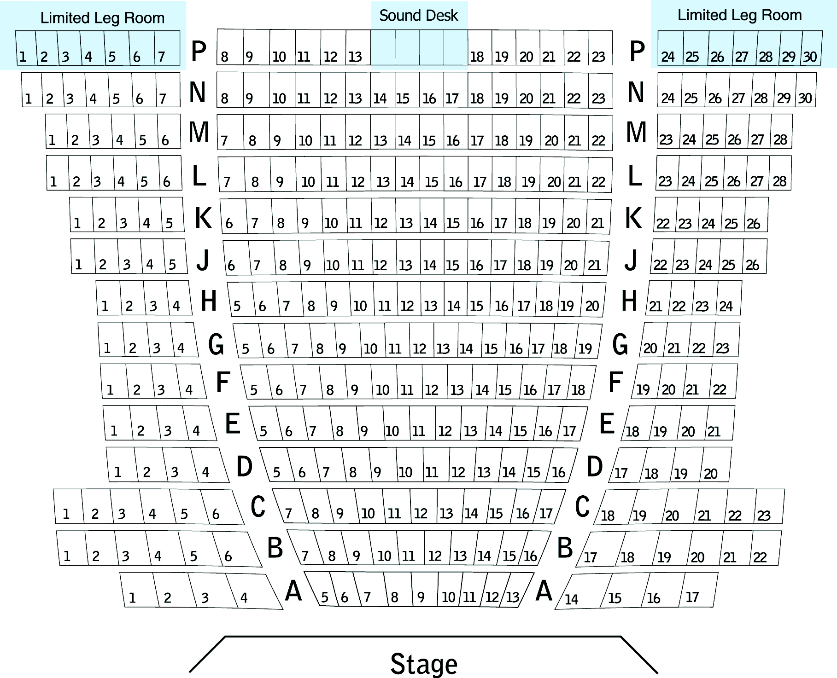

SEATING PLAN FOR STUDIO
