
Courtyard Gallery - Hire Information
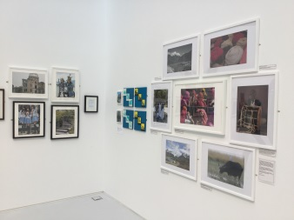
The Courtyard Gallery and Art Space is an exhibition space as well as an area for creative activities situated at the centre of The Core in Solihull. During the opening hours of exhibitions there will be regular classes and activities taking place in the Courtyard which will make it a vibrant space throughout the week
with a diverse audience and user base.

If you are interested in holding an event or activity as part of your exhibition, for example an artist talk, demonstration, or workshop we would look to accommodate this activity as part of the programme. Please discuss any plans either at time of booking or at least six weeks prior to your exhibition opening.

Exhibiting in the Courtyard Gallery
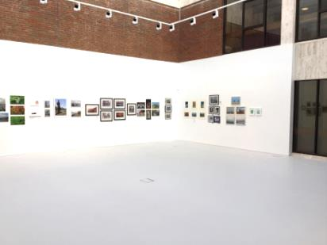
The space will be used for wall-based work, with a limited number of display
cabinets. Any plinths or display stands should be provided by the artist and the positioning and security of floor-based work will need to be agreed with the
venue’s staff on the day of installation.

Gallery Wall Dimensions
The Gallery walls take up the rear half of the Courtyard with the rear wall being 12 metres long and the two side walls being 6 metres long. Height of walls for exhibiting on is approximately 4 metres.

Venue Hire
The hire period is three-week hire (20 days) unless agreed separately with the
Venue Management.

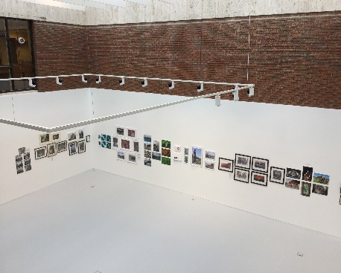
The three week hire fee will be £378 from 1/4/2025 – 31/3/2026
Gallery hire charges are subject to price increase on 1st April each year.
The hire fee will be payable on invoice which will be issued during the hire period.
Hire periods commences on a Tuesday and finish on a Monday.

Installation and take down times.
Shows are hung on a Tuesday between 9am-4.30pm and taken down on a Monday between 9am-13.30pm.
Work should be mirror plated unless another hanging mechanism is agreed at time of booking. Velcro and sticking pads are not allowed in the space.

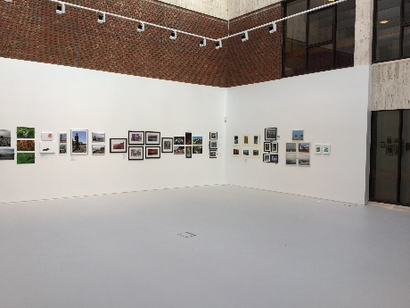
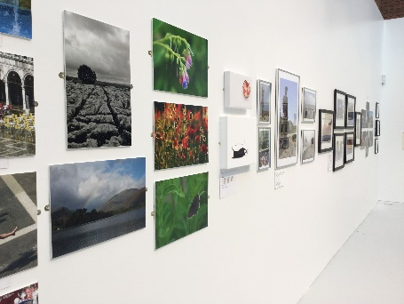
For the next available dates, please contact Cultural Programme Manager Jenna Harvey via email – jenna.harvey@solihull.gov.uk

Opening Times
Monday 9am – 4.30 pm
Tuesday 9am – 4.30 pm
Wednesday 10am – 4.30pm
Thursday 9am – 7.30 pm
Friday 9am – 4.30 pm
Saturday 9am – 4.30 pm
Sunday Closed
The Courtyard Gallery is also open in the evenings when performances are on in the theatre.

Sales of work
Artists and hirers will be responsible for the sales process of their own work on a no commission basis. The venue cannot manage any sales, sales instruction leaflets can be left with Box Office staff to pass on to visitors.

Publicity
Full listings of Courtyard exhibitions will be available on the venue’s website www.thecoretheatresolihull.co.uk Please ensure copy and an image is sent at time of booking for use on the website.
If hirers wish to display a poster, a frame for this purpose is located on the wall to the right of the entrance to the Courtyard gallery. An A – frame display board may be situated in Theatre Square subject to agreement in advance.
Publicity Display Arrangements for Exhibitions
- 1 x A3 size poster in large frame to right of Courtyard gallery entrance door
- Stand up display and leaflet dispenser 1 x A4 poster plus A5 or smaller leaflets.
- 1 x 6ft black fabric board for display, requires Velcro for fixing (please do not use blu-tac).
- Exhibitors providing own A-frame are responsible for bringing it in at night.

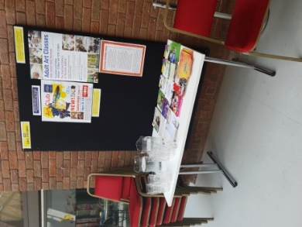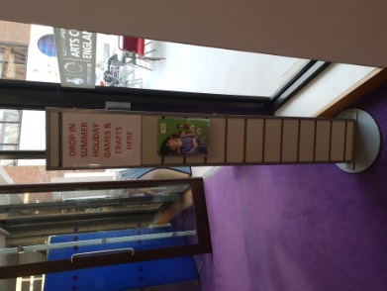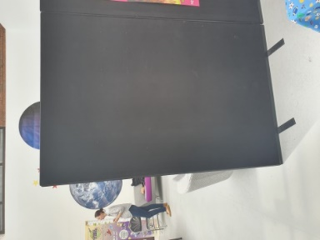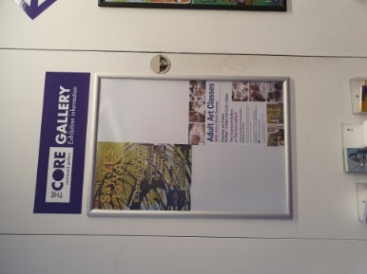
Gallery Info board Foyer info pillar Black Velcro board Foyer wall notice

Private View
Exhibition private view can take place in the evening when there is a performance, or on a Thursday evening during late night library opening. Please contact the venue if you wish to hold an evening opening to confirm availability.
Encore, our in-house eatery, and catering service can provide catering packages for your exhibition opening if required.

Catering Options
If when you are opening your exhibition, you would like to serve drinks for attendees you can either book these through Encore Café Bar or bring your own drinks and pay a £60 corkage fee for glasses and a staff member to serve. Alternatively Encore Cafe Bar will remain open for attendees to purchase their own drinks.

Drinks Packages
Fairtrade tea, filter coffee £2.25 per person
Coffee/tea and handmade cake £5 per person
Coffee/tea muffin or pastry £4.25 per person
Add biscuits 50p per person.
Orange juice jug (serves approx. 6) £5 per jug.
Red, White, or Rose wine (served) £5 per glass.
Prosecco (served) £6.50 per glass.
Selection of cordials 75p per person
Bottled water still/sparkling £1.50 per bottle.

